
Vol. 2
No. 2
1880

DEVOTED TO THE INTERESTS OF WALWORTH COUNTY,

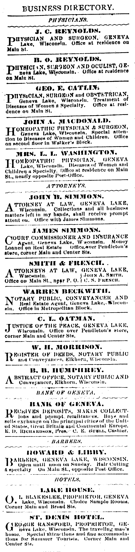
COUNTY ITEMS

From our regular Correspondents.

ELKHORN

--The total receipts of the Walworth County Agricultural Society, at its 30th Annual Fair, was about $5,500—about $500 more than ever before.
--An interesting feature of the Fair was the presence of a telescope of considerable magnifying power, by which many were enabled to see for the first time Jupiter’s moons and Saturn’s rings. The gentlemanly superintendent of this primitive observatory had all the customers he could attend to on those clear and starry nights.
--If there has been a time since the deluge [biblical flood] when the water fairly piled up on the hilltops, perhaps it was last Monday.
--A “washout” near Durand, last Monday, occasioned a little flurry among the section men even in distant Elkhorn, but under the prompt and efficient administration of Roadmaster Briggs the gap was quickly closed and trains running regularly on time.
--The Walworth Glee Club, whose grand concert was postponed on account of the weather and political excitement, week before last,, will give a musical entertainment at Warning;s Hall, this week Thursday evening.

LYONS

--Mr. W. Foot, of Spring Prairie, started Monday afternoon for Kansas with three carloads of sheep. This is the second time he has been West this fall with sheep.
--Mrs. Parsons is gaining very slowly. Dr. Kords, of Burlington, is attending her at present. He thinks the bone was broken. Now the question arises who will decide when doctors disagree.

SHARON.

--School opened at Walworth Academy last Wednesday, with Prof. Burdick as principal.
--Old Mrs. Kelley, of Walworth, has the typhoid fever, and some doubts are entertained as to her recovery.
--The Geneva croquet club has challenged any other club in the State to play a matched game against them. We have the stuff in Sharon that can make the Geneva club howl, and we should like to see the boys try it, too.

SPRING PRAIRIE

--Chas. Stubbs was called to Darien at the close of last week to attend the funeral of his mother, weho died on Friday the 3rd inst.
--Grand review and press parade of the milk brigade at the store of Messrs. Hubbard & Puffer each morning lasting from nine to eleven A.M.
[Does “Messrs.” seem like a silly abbreviation? It’s only one letter shorter than “Misters.”]
--Several gentlemen from East Troy and elsewhere were in town last week, looking for a suitable route for the proposed R.R. from Waukesha to Geneva Lake.

THE PAST WEEK.

DOMESTIC NEWS.

An accident on the Boston & Fitchburg railroad resulted in the death of two passengers and injuries, more or less serious to 15 others.
Joseph Mehrens and wife were riding home from La Crosse, Wis., when a spark from the former’s pipe set fire to the straw in the wagon-box, and both were fatally burned.
A Pittsburg dispatch of the 12th says the deaths by the direful accident upon the Pennsylvania railroad now number 27, and eight of the others are not expected to survive. The whole city is mourning for many among the killed were well-known and widely connected.
George Lowrey and David Thomas have been hanged by the citizens of Nelson county, Va., for having grossly assaulted and robbed a widow named Massie.
The Herald

HEG & NETHERCUT, Publishers.

GENEVA LAKE, NOVEMBER, 1880

For President,
JAMES A. GARFIELD
of Ohio.

For Vice President,
CHESTER A. ARTHUR,
of New York.

The Chicago Convention.

The convention at Chicago occupied all the time last week until Saturday night, in getting things in working order. Most of the time was spent in adopting the Credential‘s report, there being contesting delegates in several states and territories. On Saturday evening, however, the Convention was ready to proceed to receive the names of candidates for nomination. The roll of the States was called, and when it reached Michigan, Gov. Joy, of Detroit, nominated James Blaine, followed by a short speech.
The name of Senator Windom, of Minnesota, was then presented by his State’s delegate, with no seconding. Senator Roscoe Conklin followed with an eloquent oration for the “silent old soldier”, which was applauded from beginning to end. The whole speech was an effort that one hears but once in a life time. With the exception of Conklin, Garfield was the best orator of the body, and the most popular with the crowd. By this time it was nearly midnight and the Convention postponed voting until Monday, to the intense disappointment of thousands.

The Republican National Convention, which after nominating General Garfield for President Tuesday, proceeded to a nomination for Vice President. Speeches were made, presenting several names. Only one ballot was taken, resulting as follows:
Arthur, New York …………………………468
Washburn, Illinois …………………………193
Jewel, Connecticut ………………………….44
Maynard, Tennessee ………………………..30

The Fortieth Annual Session of Fox River Association of Universalists, is to be held at Aurora, Illinois, on the 9th through the 11th.
FARM and HOME.

Farm Rakings

Harvest sermons are preached on Sunday in the interior of Pennsylvania, where thanks are returned for the bountiful harvests.
The Bohemian hulless oats have not given satisfaction in medina county, Ohio,, where they were tried this season by a number of farmers, who paid $10 a bushel for the seed. The yield was insignificant. The season was not as good as usual.
Which is better for transplanting, spring or fall? Our answer would be, spring, north of this latitude; fall, south of it. This is in reference to deciduous, fruit and ornamental trees.

LURID FLAMES.

J. E. Burton’s Elegant residence on Fire.

On Sunday evening people as were returning from church they were startled by hearing an alarm of fire, and stilln more so when they learned that the fire was in Mr. Burton’s new and elegant residence opposite the public square. There was soon an excited crowd of men, women and boys around and in the building, every one of whome seemed to be working on some indefinite plan of his own. The crowd first rushed all over the house without a drop of water, and then all of them rushed out doors yelling wildly and calling for someone to bring water and ladders. Finally by the superhuman efforts of two or three cool headed individuals, a water line was formed and the work of quenching the flames began. The fire was caused by a defective flue. It seems that the chimney was built with a place to put the ash box, but by some oversight this cavity had simply been filled with loose brick and the wainscoating built over it. The soot accumulated in the vicinity catching on fire set the woodwork back of the bricks on fire also. Mr. Burton noticed that the chimney was on fire and that the woodwork about it was very heated and he cut a hole in the side wall and poured in water supposing he had put out the fire. Shortly afterwards, however, watchman Kelley noticed smoke from the upper windows and the alarm was given again. At one time it seemed impossible to save the house as the fire had caught in the timbers of every story in the south-west corner. The third story was badly burned and the mansard roof almost completely destroyed. The furniture, carpets, etc. were all removed, but so hurriedly that they were badly damaged. Mr. Burton had a collection of coins on the fourth story which was valued at $4,500, all of which was removed with the loss of only a few hundred dollars.
The house was build three years ago at a cost of $12,000, and the furniture and goods were worth about $3,500. An insurance of $11,000 was on everything.

Brown, the Great Mind Reader!

Mr. J. Randall Brown, the celebrated mind reader, arrived in Geneva on Wednesday, and is stopping at the Whiting House, where he will remain a few days resting, prior to starting an extended tour throughout the northwest. Mr. Brown has traveled quite extensively throughout this country and Europe since his last visit to Geneva, several years ago, when he gave us one of his wonderful entertainments, which at the time created a great sensation. He has added very much to his entertainment since he appeared among us and what he did at that time was child’s play compared with what he does now. The scientific men of the East, among whom may be mentioned the faculties of Yale College and Harvard College, endorse Mr. Brown in the highest terms.
He has added to his programme of mind reading, a series of the latest so called spiritualistic manifestations, which he explains upon scientific principles. Spirits are made to appear before the audience, messages received from the dead, and the spirits cause the tables and furniture to move about, while the sweetest music is discoursed by the phantom orchestra.
The price of admission has been placed at a low figure, only 35 cents to all parts of the house. Reserved seats without charge at Hammersley’s.

Lectures to Ladies.
Mrs. D. A. Beale will give a course of lectures on Physiology and Hygiene to the ladies of Geneva and pupils at the Seminary, as soon as arrangements can be made as to time and most convenient place. Those desiring tickets will please address Mrs. Beale by postal card. Tickets to the course $1.00.

Local Department.

DIRECTORY

CHURCH OF HOLY COMMUNION (Episcopal)—Rev. Richard T. Kerfoot. Sunday Services: Holy Communion at 7:30 A.M.; Morning Prayer & Sermon at 11:00 A.M.; Evening Prayer & Sermon at 7:30 P.M.; Wednesday evening at 7:30 P.M.
METHODIST EPISCOPAL—Rev. Thomas Clithero. Class meeting every Tuesday evening. Prayer meeting every Thursday evening. Services every Sunday at 11:00 A.M. & 7:00 P.M.
GERMAN METHODIST—Rev. Wakerlin. Services (in the Methodist Church) every other Sunday at 2 P.M. Prayer meeting every Sunday at the residence of Mr. L. Stauffer.
PRESBYTERIAN.—Rev. D. L. Holbrook. Prayer meeting every Wednesday evening. Services every Sunday at 11:00 A.M. & 7:00 P.M.
WESLEYAN METHODIST.—Rev. P. B. Campbell. Services every Sunday at 11:00 o’clock A.M. Prayer meeting every Thursday.
CATHOLIC.—Rev. N. M. Zimmer. Services e very Sunday at 10:30 A.M. Vespers at 4:00 P.M.
BAPTIST.—No regular pastor or meetings. Sunday school at 12:30 P.M.

The residence of Dr. B. O. Reynolds is receiving a new coat of white.

Hatch’s repair wagon, filled with brand new eaves troughs, due here Nov. 15.

Quite an extensive new wing is being added to the Presbyterian parsonage on Geneva street.

Storm doors have been added to the Whiting House this week preparatory to cold weather.

There was but very little scratching done this year, as out of 640 tickets, 620 were straight.

John Fluker has returned to town and opened a barber shop in the basement of the Metropolitan block.

Linn [township] gave a Republican majority. The vote stood: 137 Republicans to 46 Democrats.

Work has been commenced on the new bridge to be built across the outlet on Center street. The job is being done by Mr. William Moon.

As apples are so very plenty and as they do not keep well, we must decline
receiving any more on account. We cannot make use of any more.

The bank has a new sidewalk and so has the house in which Mr. Joseph Quigley is moving.

Send us the names of those of your friends in the country who do not take the HERALD that we may send them the paper for a month, free of charge.

GLORIOUS VICTORY

A SOLID NORTH AGAINST A SOLID SOUTH, THANK GOD!

NO CHANGE WANTED.

The election on Tuesday proved to be a most decisive victory for the Republicans. In fact the result was far better than anyone had reason to hope for. The returns are not fully in, but enough so to know that every Northern State with the possible exception of New Jersey and California has gone Republican by majorities, nearly double what was expected.
California is in doubt; the Democrats claim it, but there is every reason to believe that it will be Republican by at least twenty-five hundred majority.
Wisconsin comes to the front as usual with thirty thousand or more, majority, and a gain of one Congressman, Guenther being elected over Bouck in the sixth district.
The lesson that this result gives is one that any one may understand:
It means that the industrious, hardworking men of the North are not willing …
blah
blah
blah.

NOW DO IT.

There has been much talk in the past three or four years of the necessity of fixing up the lakeshore in the village that it may be attractive to visitors. As a beginning, the little patch of green at the foot of Broad street was ornamented so that now it is really a pretty little place and one that many of our citizens enjoy during the warm weather. The triangular piece of land known as “Walter’s frog pond” has, however, been an eyesore to many of our citizens, and it has been said time and again that it was a breeder of missma and malaria, and that it drove many of our summer visitors. It was generally understood that it could not be bought and numbers have fairly howled for the Board to declare it a nuisance and condemn it to turn it over to the village to be improved. Now it is for sale. Mr. Walters offers to dispose of it at a fair price to either the village or private individuals, and now is the time to get it and fix it up so that it shall no longer be an eyesore or a stench in the nostrils of the village. The fish pond can be filled up for almost nothing by the village, for the Street Commissioner is in want of a place to dump all the tin pans, oyster cans, corsets and crinolines that the average free-holder annually heaps up in the streets, and one good Spring would be enough to fill up the hole. Then the sheds, boat houses, etc. should be bounced and the place made ready for any kind of use, and it would be a thing of beauty and a joy forever.

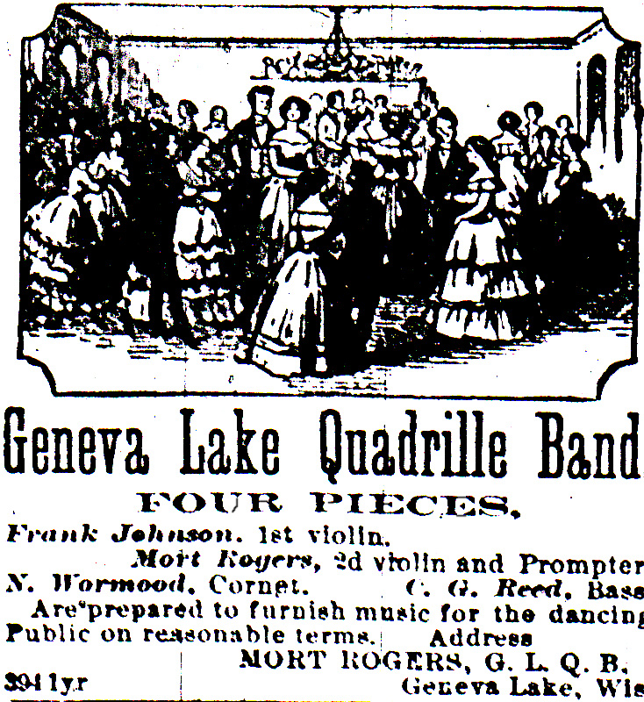
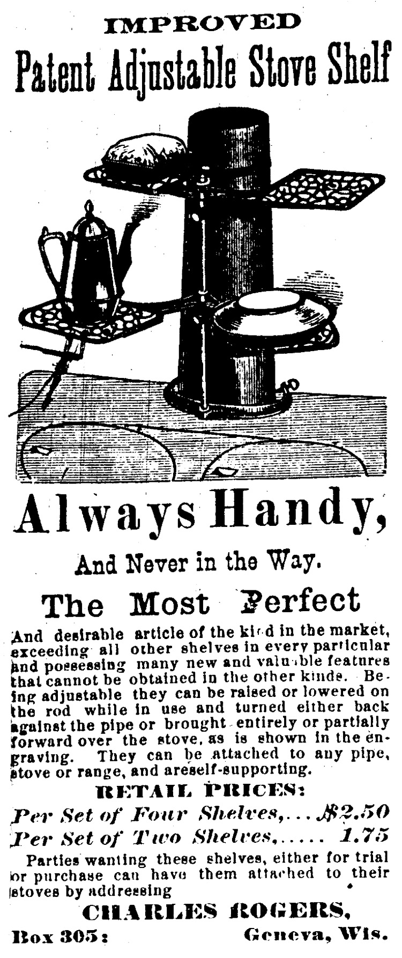

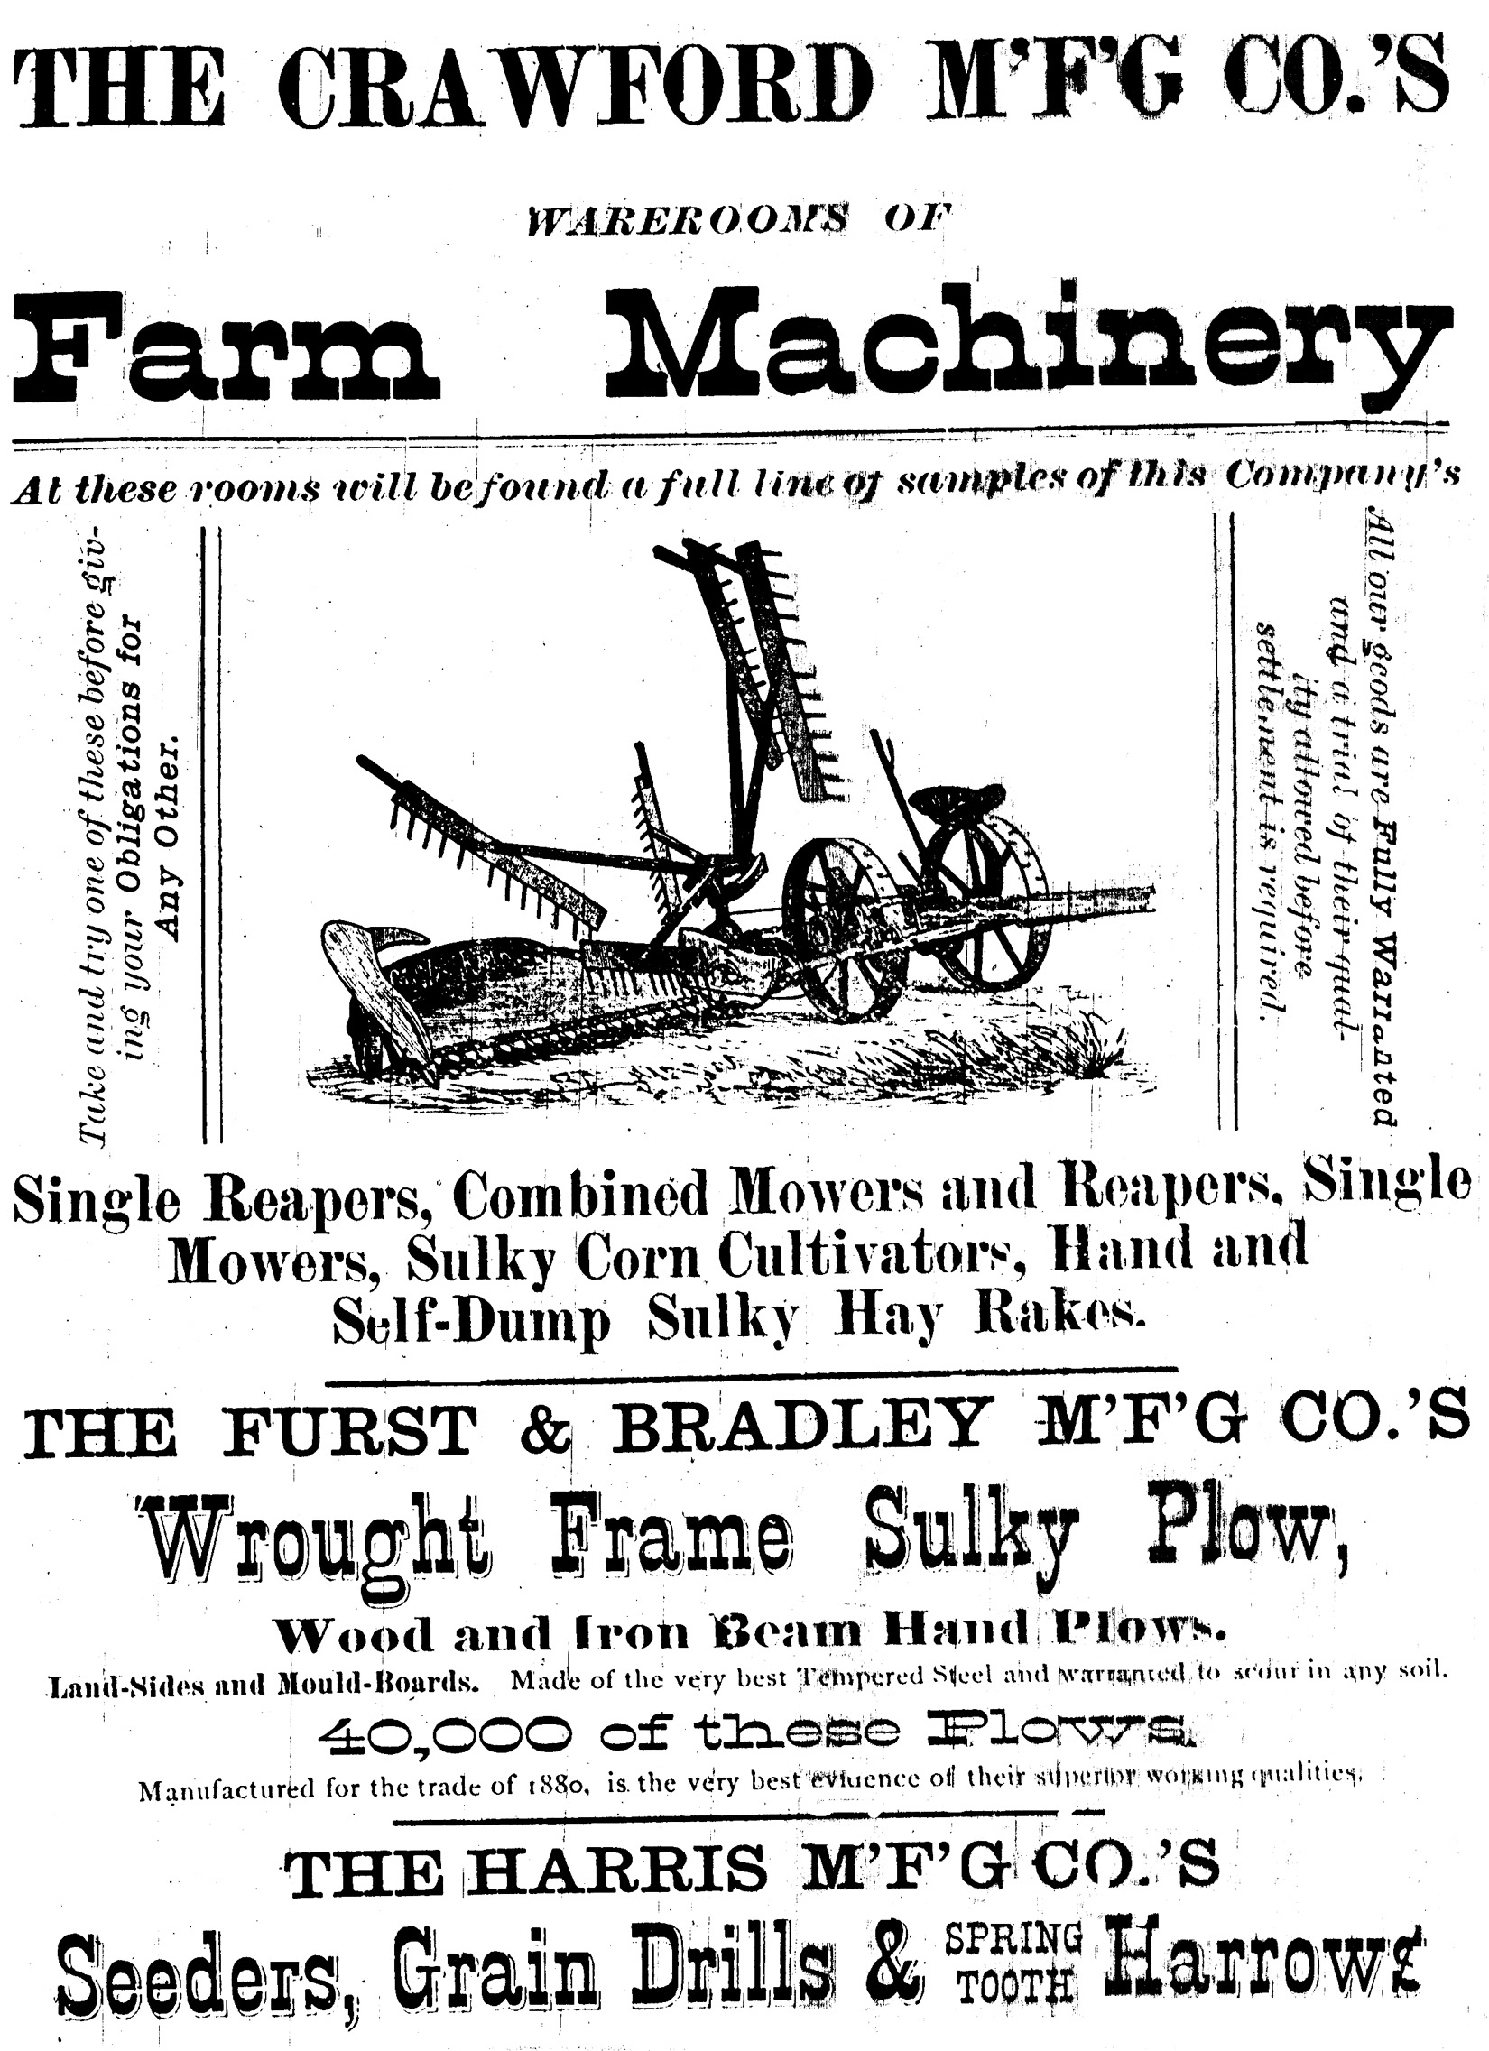
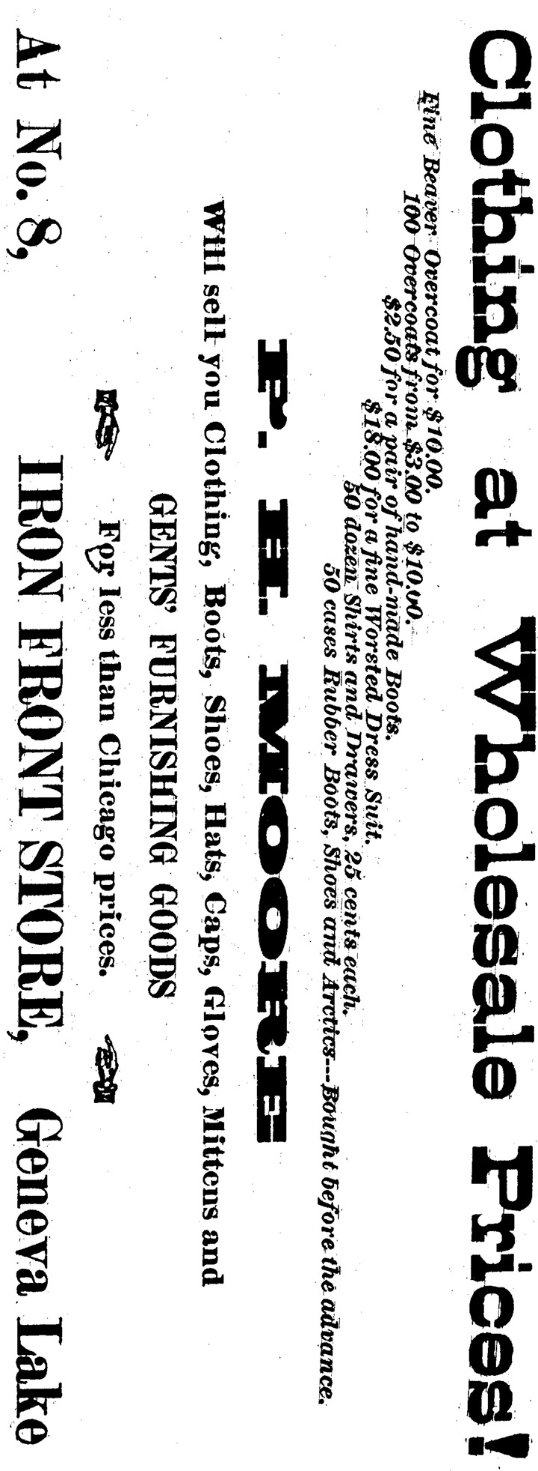
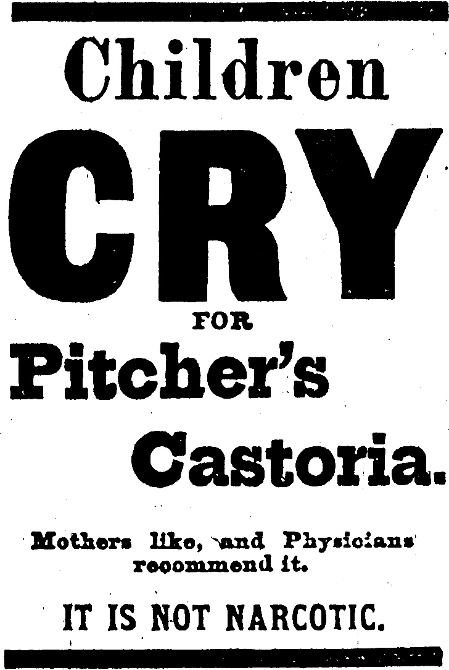
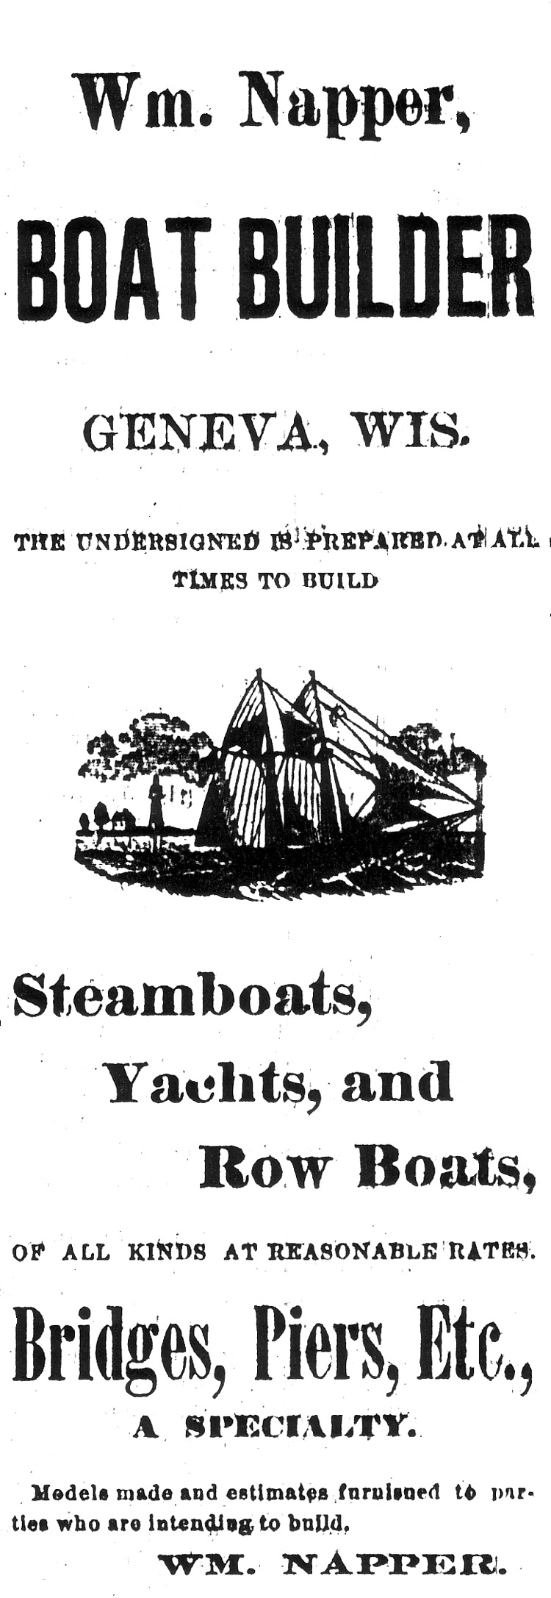
The Lake Geneva Old Times is sponsored and financially supported by the Lake Geneva Historic Preservation Commission. Each issue represents one year of authentic old news. It is free to the public. The public may obtain copies at the Geneva Museum, Grandma Vickie’s Café, Dunn Lumber, Piggly Wiggly, Caribou Coffee & Starbucks. Back issues can be purchased for 50 cents each.
Editor, Denny Teichow, 262-248-6313.


