Vol. 3 - No. 5
Whole No. 29
Lake Geneva, Wisconsin, August, 1895

Hi. Sandy & I have returned from our teaching adventure in Minsk with a collection of new stories. If you're curious, you can be regaled in the comfort of your own home with fascinating tales of Belarussian culture for the mere price of a steak dinner.

In 1895 work on the Yerkes Observatory continued, the U. S. won the Americas cup, again, the L. G. Herald put out a special women's edition, Japan has won a war with China and we find out how dangerous Geneva Lake can be. Enjoy. D.T.


TWELVE MILLS FAIL.

Forced To The Wall.

The North Dakota Milling Association of Grand Forks made an assignment Thursday to Wm. Honey. The Mandan Roller Co. has made an attachment on the association to secure payment of a $100,000 debt. This attachment and mismanagement are causes of the assignment. The assignee will continue the general offices in Grand Forks until the affairs of the association are closed up.

OPEN to the WORLD.

RESULTS OF THE JAPANESE CONQUEST OF CHINA.

The Immense Empire to Be Thrown Open to Foreign Commerce and Her 400,000,000 Inhabitants to Compete with European Labor.

The Japanese minister at Washington confirms the reports from Tokyo that his Government has made the opening of China to foreign commerce and immigration one of the conditions of peace, which will make the country the most attractive spot on earth for investments and speculation during the next ten or fifteen years. The interior of China, and, as a matter of fact, the entire empire, except for the treaty ports, is 2000 years behind the age, judged by comparison with France or Great Britain or the United States, but with its marvelous soil and 400,000,000 of a naturally ingenious and industrious population it is capable of almost any degree of development.

[Well, the time frame was off by a whole century, but this prediction is certainly coming true.]

RUSSIAN BEAR GROWLS.

May Interfere with Japan's Scheme

to Squeeze China.

The St. Petersburg Novoe Vrema says that if Great Britain has approved the territorial demands of Japan in regard to Manchuria and Corea, Russia will consider herself relieved of the obligations of common action and will oppose Japan on land and on sea.

BIG BANK GOES DOWN.

Cattle Rustlers Assault and Lynch a Woman.

The National Bank of Kansas City, Mo., one of the oldest banking institutions there, did not open its doors Monday morning. The failure did not come as any surprise in commercial circles. They quit with nearly a million dollars in shortage.

Some time Friday Mrs. W. E. Holton, a respectable woman living alone on a ranch in an isolated part of Nebraska, was lynched. The crime is credited to vigilantes of the district who believed her in league with cattle rustlers. Some think the rustlers committed the crime in revenge for evidence against them furnished by the woman. She had evidently been assaulted. Everything points to a premeditated plan for the perpetration of the dastardly deed.

New Canal Scheme.

The Illinois House introduced a bill looking into the construction of a ship canal from Lake Michigan to the Mississippi River via the Des Plaines and Illinois Rivers. By its term the bill authorizes the Governor to appoint a commissioner of waterways, who shall be an engineer of recognized standing on the waterway question.

Race Riot in Georgia.

After the killing a negro at Forsythe, Ga., by a sheriff and three deputies, a mob of armed negroes threatened to make an outbreak. They had the three deputies arrested for murder.

Dogs of War Muzzled.

Upon representations that citizens of Nicaragua were making an honest effort to raise $75,000 to pay the Hatch indemnity, Great Britain granted a two day extension to give them a chance to make up the amount.

Nitro-Glycerine Explodes.

William Ulmer started Friday morning from Bluffton, Ind., to the Montpelier oil fields with 750 quarts of nitro-glycerine in a wagon. When two miles from Bluffton the wagon wheels struck the root of a tree and upset the wagon. An explosion immediately followed, which made a hole sixty feet across and fifteen feet deep. Ulmer and his horse were blown to atoms. Window glass was broken in houses for miles around, and the shock was felt in Fort Wayne, twenty-five miles away.

Starts on a long tramp.

John Rigoulet started Friday to walk from San Francisco to New Orleans, nearly 3,000 miles.. He is a French architect. He lost all his money in a Midwinter Fair concession and members of the French colony arranged to send his wife and two children by rail to New Orleans. Rigoulet decided to make the trip on foot, and will have two companions in similar circumstances. He started with 5 cents and a pack.

Open to Settlers.

The President Thursday signed the proclamation declaring the Yankton Sioux reservation in South Dakota open to settlement at noon Tuesday. The land office, it is understood, has already placed itself in readiness to carry out the provisions of the proclamation. The reservation embraces about 168,000 acres of the best lands in the Dakotas.

["Reservation" - from "reserved" meaning saved for someone in particular. The United States government broke almost every treaty it ever made with the Native Americans.]

Caught the Coot.
ANGRY WOMAN CHASES AFTER A WORTHLESS HUSBAND.

Chased Him Over the World.

Mrs. Nancy Tomlinson, of Ansonia, Conn., was swindled out of $7,000 by W. J. White, the alleged bigamist. She said that ever since the indictment by the grand jury last year, she has been on White's trail. She followed him to Scotland. Then chased him through England, and was one steamer behind him when he went to Australia. She then traced him back to the Pacific coast and on to Michigan, where he was arrested. She said she had spent $5,000 and a year and a half in trying to run White down. She learned that he deserted Agnes Malcom in Brooklyn a few years ago. Mrs. Tomlinson first met White in 1893 and she admits that she still loves him better than she did her first husband. It appears that White offered the deputy sheriff $1,000 to let him go.

PUNISH THE NATIVES.

BRITISH DESTROY VILLAGES IN SOLOMON ISLANDS.

Summary Vengeance.

John Carter, an ex-seaman of H. M. S. Royalist, has arrived at San Francisco. From Sydney, where the Royalist is now stationed. England, according to the seaman, took very drastic measures in the punishment of the natives of the Solomon group of islands. The village at the Soy River was cannonaded. A landing party had started from a nearby village and drove the savages into the interior. A number were slaughtered. The trouble was brought about by the murder of Donald Guy last April and the murder of eight inebriated English tars who went ashore to enjoy a good time. The Royalist in ten minutes literally wiped the village of Soy off the face of the earth. The Royalist then steamed to the Island of Malayta and turned her guns on the village of Altai. A number were killed or wounded. One after another three villages were destroyed.


THE CUP AGAIN OURS.
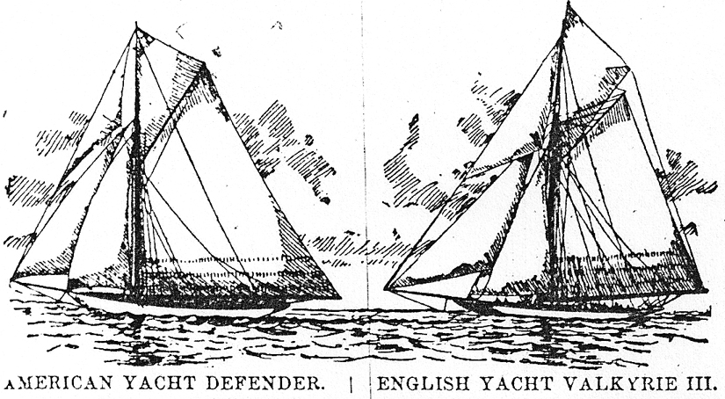

VALKYRIE HAD NO CHANCE AND DUNRAVEN KNEW IT.

Story of the Fiasco.

New York Correspondence:

AGAIN the America yachting cup stays on this side of the Atlantic and the British, who have vainly tried since 1851 to wrest it from our Yankee boats may this time add to discomfiture over failure, chagrin attaching to childish behavior of their champion. In the first heat the Defender out-sailed the Valkyrie so clearly on every point that it was confidently expected that she would win three straight heats. Just before the start of the second heat, the British boat, possibly not intentionally, but nonetheless in violation of the racing rules, fouled the Defender, and crippled her so that she could not carry two of her sails. Valkyrie crossed the starting line nearly two minutes ahead of Defender; but crippled as she was, that gallant yacht gave opponent such a chase that at the finish there was but 47 seconds between them. But the club committee, conforming strictly to the rules, gave the heat to Defender, and it is believed that this is what caused the remarkable display of pettishness on the part of Lord Dunraven in Thursday's contest. He made no attempt to put his boat in racing trim, but loafed across the starting line with short canvas. Hardly had he made the start when he put about, and with the signal of acknowledged defeat flying, laid his course for the club house. The Defender saild the course alone. Dunraven alleges as the cause of his actions that he was hampered by excursion boats.

Earl Dunraven gave an exemplification Thursday of the English sportsman that is not pleasant to the American eyes. The attitude of sulker and churl is not a creditable one under any circumstances; in the field of international sport it is at once disgraceful and disgusting.



THE HERALD

~~~~~~~~~~~~~~~~~~~~~~~~~~~~~

JOHN E. NETHERCUT.

--Mrs. T. C. Smith has raised up her barn and built a new foundation under it.

--The work of cleaning up the Whiting House ruins has been continued and all the debris will soon be carted off and the cellar filled.

--A number of new planks have been put in the crosswalks this week--a very proper thing to do.

--One boy was sent to the reform school at Waukesha on Monday, but there is about a dozen young hoodlums who ought to go there, still left.

--Charles Rogers mourns and refuses to be comforted. His old horse got tired of living by faith alone, so he lay down and gave up the ghost, hence those tears.

--The Lutheran society of this place will hold its annual missionary festival on Sunday, August 11, and extend a cordial invitation to all to attend.

--We have many complaints about wells hereabouts going dry. The one at C. S. Arnold's place some years ago had fifteen feet of water in it, but now there are not that many inches.

--The proprietor of the Lake Vista House at Williams Bay will give a birthday party in his dining room to-night. So far his parties have been very pleasant affairs and this one will prove no exception.

--It will cost you nothing to stop by the "Feast of Nations" and look at all the pretty things displayed by the ladies in Turkish, French, English and German costumes.

--The Congress Club people are going to give a very fine dance Friday evening. Johnny Hand's orchestra will furnish the music and a Chicago caterer will have charge of the refreshments.

--The Walker Block is progressing finely. Work has begun on the second story.

--Go 'round the lake for twenty-five cents. Steamer leaves the private pier at 3 p.m., returning at 7:30.

--The fountain which the Y.P.S.C.E. maintains opposite the store of M. M. Swan on Main St., is the source of a great deal of pleasure to many thirsty people.

--Every third man we met Monday morning had a package of glass under his arm and a lump of putty in his hands, going home to put in his "lights" which the storm had blown out

THE SUNDAY STORM.

A PARTY OF PLEASURE SEEKERS DROWNED WHILE BOATING.

One Body Recovered, No Trace of the Others or of the Steamer Obtained. Still Dragging the Bottom.

A party consisting of Rev. Hogan and sister, John E. Hogan, wife and child, of Elgin, Ill., chartered the steam launch Dispatch, belonging to the Lake Geneva Steamer Line, last Sunday, for a pleasure ride around the lake. They took possession of the boat at Kaye's Park about 1:30 and steamed leisurely around the south shore to the city. Here they remained for some time. They left the dock for the trip around the north shore at 4:20. Before they started the clouds had begun to gather in the west and there was every appearance that a severe wind storm would break upon us before very long. When they had proceeded up the lake as far as Elgin Park the storm had begun and the parties standing on the pier at that point, state that the boat passed within 15 feet of them. It kept the course for some distance past the pier when it was seen to swerve, as if to make for Crane's pier. Changing their course again they kept out into the lake for a few moments, when they changes course again as if to run into Cooke's pier. It seems at this point a firm decision was arrived at and the boat was headed straight for Kaye's Park.

All this time the storm was gathering and when the small craft had reached a distance of perhaps half way across the lake the rain and hail came down in such quantities that it was impossible for those watching from the shore to see anything at all. When it cleared up there was no Dispatch in sight, she had sunk in 150 feet of water with all on board. As soon after the storm as possible nearly all the steamers on the lake joined in the search for the boat. Cushions and life preservers were seen floating on the water off from Black Point. Near Cedar Point one of the small steamers discovered a body floating in the water. The search continued until dark, but found no trace of the boat or of the passengers.

Who Is He?

An advertisement in the last Delavan Republican reads as follows:

A Lake Geneva Widower IS Desirous of forming the acquaintance of a middle aged Delavan lady. Object matrimony.

Now who can this Lake Geneva widower be, and why does he not first give home maidens and widows a chance instead of offering of offering to reduce the surplus female population of Delavan? Does he intend to insinuate that the middle-aged ladies of Geneva are not good enough for him? He deserves no sympathy if he gets a red-headed termagant who makes his life a burden.

The Women's Edition.

The women of Lake Geneva have made arrangements to get out a woman's edition of the Herald. The object of this enterprise is to raise money to be used in beautifying our city, and ultimately, the erection of a library building. It is a laudable object and one in which every citizen should take an interest. There are many theories about improving the appearance of Lake Geneva, but it is cash, cold, hard cash, which will put the theories into practice.

The women have arranged to publish an edition of 5,000 copies. It is expected that all our merchants will take a liberal amount of advertising space, as the paper will have a guaranteed circulation of 5,000 copies.

It is understood that the women do everything towards getting out the paper, except the mechanical part, which will be attended by the Herald force. The ladies are very anxious to make their issue the neatest and best, together with the most profitable woman's edition ever published.

[The next issue of the LGOT will be entirely from the woman's edition.]

Telephone Rates Lower.

Manager Willitz informs us that a sweeping reduction will be made in the rates for telephone rentals and in toll line charges. The rates that are to prevail here are: phones for business houses $36 reduced from $48; residences $24 reduced from $36 a year. The rates for metallic circuit and long distance telephones will be $60 for business and $42 for residences.

Mr. W. informs us that the new metallic circuit will not run to Genoa as has been stated, but will run to Racine from here and there to connect with the main line.

Mrs. Walter McAfferty died in her home in this city on Wednesday, after an illness of some months.She was formerly Miss Sarah Anna Gragg, and was born in Livingston county, New York, 29 years ago and came to Wisconsin. In March 1888 she married Mr. McAfferty, who with one child, six years old, survive to mourn her early death.

Scarcity of Water.

The Burlington Standard says:-- There promises to be a scarcity of water for running the mil at Lyons and the mill and and electric light plant in this city unless the Lake Geneva Water Power & Lake Level Protection company are prevented from carrying out their plans. The company with the long name has shut off the water from Lake Geneva and proposes to raise the water level of the lake. Legal steps will be taken to make the company desist.

The drop in butter, of fully ten cents, in about two weeks, has had a depressing effect on our dairymen and some predict blue times for our dairy farmers. It is a fact that those engaged in dairying have felt the effect of hard times less than any other industry, but now it looks as if the fork in the road has come. Meanwhile the butterine makers stand aghast at the decline in the price of butter as butterine is driven out of sight by the low price of the real article.
The Lake Geneva Old Times is sponsored and financially supported by the Lake Geneva Historic Preservation Commission. Each issue represents one year of authentic old news. It is free to the public. The public may obtain copies at the Geneva Museum, Grandma Vickie’s Café, Dunn Lumber, Piggly Wiggly, Caribou Coffee & Starbucks. Back issues can be purchased for 50 cents each.
Editor, Denny Teichow, 262-248-6313.


Claude DeLap was married, inn Chicago, a few weeks since, to Miss Amelia Schultz. Hey will live on Mr. DeLap's farm near the Davidson school house.

Capt. C. A. Carter, the well known candy salesman for Krantz, was a caller on Wednesday. He has more friends in Wisconsin than Grover Cleveland.

We would suggest that the best use for the pictures that come with the Chicago papers is to give them to the schools. Thus children will get the benefit from them for years to come.
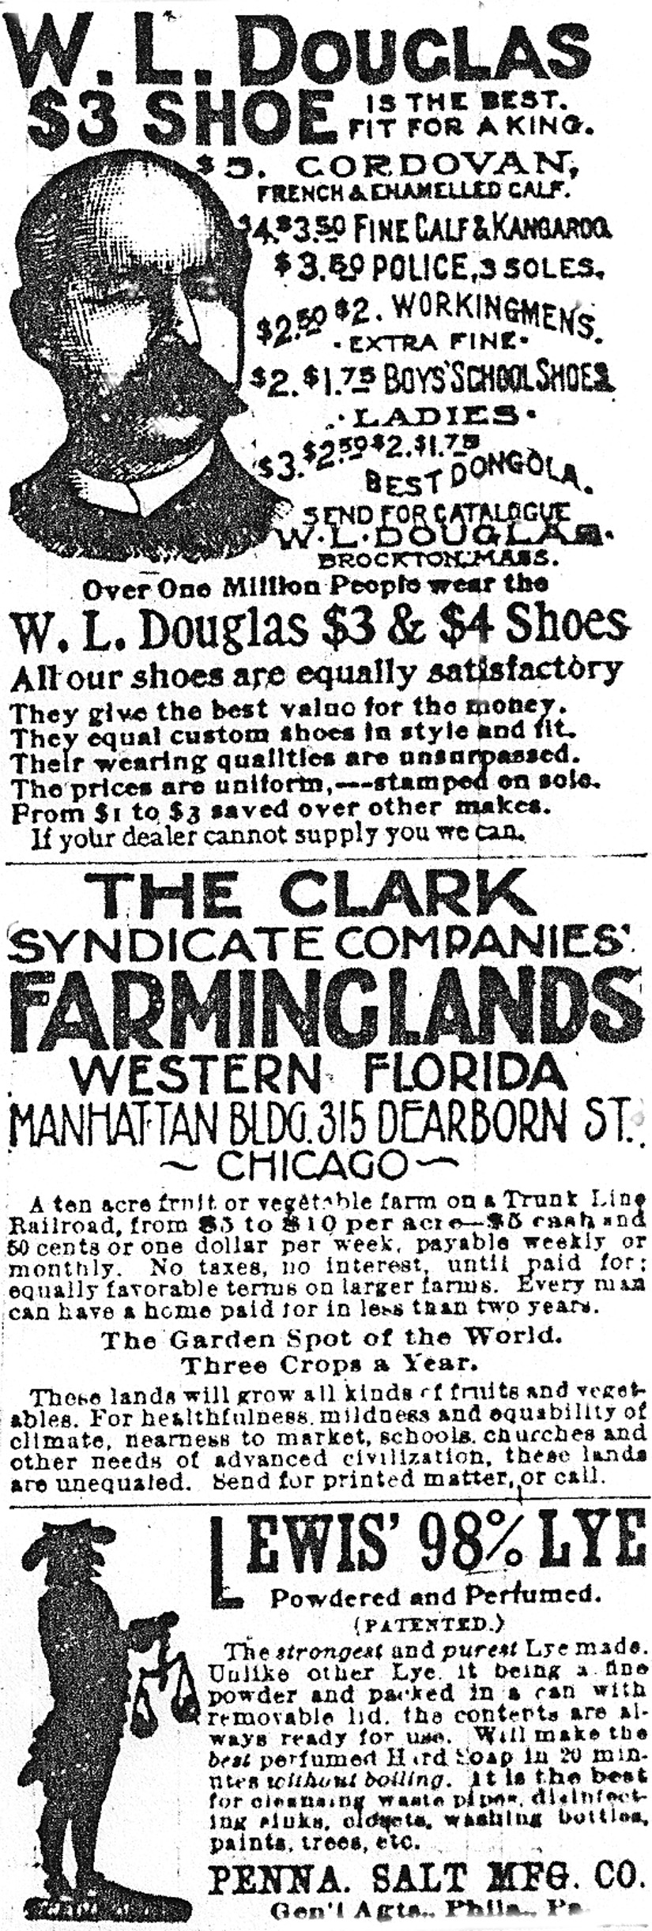

Don't forget the excursion to Devil's Lake on Tuesday. Train leaves here at 6:40 and reaches he lake at 11 o'clock, and leaves there at seven o'clock. A comfortable seat is guaranteed to everyone. There will be no crowding or delays. Don't miss it! Tickets for round trip only $1.50.





