Vol. 4 - No. 4
Whole No. 40

Lake Geneva, Wisconsin, July, 1911

In this number we skip ahead to 1911 in order to join the 100th anniversary celebration of Horticultural Hall, which celebration will take place in August. There is not four pages of news on the building of the hall so we include the results of a project I have been working on for some time, namely a map of the downtown area identifying what kinds of businesses were in various locations. To give you a frame of reference the current businesses are included and for convenience the map and the key are on the interior of this issue, which puts the Horticultural Hall story on the front and back pages. Confused? I'm confident you can figure it all out. And we have a winner for the puzzle prize in the past two issues. Ann Heinrich figured out that a three letter word for a horse, a window and a body of water is "bay" and the saying in the rebus puzzle is "Be prepared for wintry winds." For being so clever Ann won herself $10.

Gardeners Elect Officers.
Report Shows Association to Be in Prosperous Condition.

The Gardeners held their annual meeting on Saturday and elected officers and directors for the ensuing year. The reports show the society to be in a flourishing condition, with the prospect of a new building in which to hold subsequent exhibitions, here is a spirit of enthusiasm among the members.

There is no doubt that this society has been of great benefit to its members and their employers. The discussions engaged in at the meetings bring out new thoughts, suggest new methods and assist in proving the truth or falsity of theories advanced. It is hoped that work on the new building will begin soon.

Gardeners Association to

Exhibit beautiful Flowers.

At the meeting of the Lake Geneva Gardeners and Foremen's Association held Tuesday this week, it was decided to hold a peonies show at the Guild Hall. Every citizen of Lake Geneva should avail themselves of this opportunity to view the beauties of this decorative plant and to learn something about its cultivation and care. The Association is making every effort to assure a large display from outside commercial men.

AUTO ACCIDENTS.
TWO MACHINES DAMAGED LAST SATURDAY NIGHT.

S. H. Wheeler's Machine Turns Turtle at Boyd's Corner--Took Wheels off Buggy--None of the Occupants Seriously Injured--Good Road--French and Douglass Souter Had Miraculous Escape.

Last Saturday night or Sunday morning was a great time for automobile accidents hereabouts, for two machines were wrecked and the occupants had miraculous escapes from instant death.

S. H. Wheeler's machine, driven by his son, came to grief at Boyd's corner south of town. As it was it seems they met a buggy at the corner and were going too fast to make the turn with the result that the wheels were taken off the buggy and the auto thrown against the fence upside down.

As the road at that place is in fine shape, with a broad easy turn, there would seem to be but reason for the accident - too fast driving.

At about the same time Sidney French and Douglass Souter were returning from Delavan. They had reached a spot just beyond the Dummer hill when something happened, the boys did not know what; when they came too they found themselves by the side of the road with the machine on top of them. Fortunately they were not seriously injured but the machine was badly damaged. In this case as in the other, the road was in good condition, and the only solution would seem to be the breaking of a wheel and driving too fast.
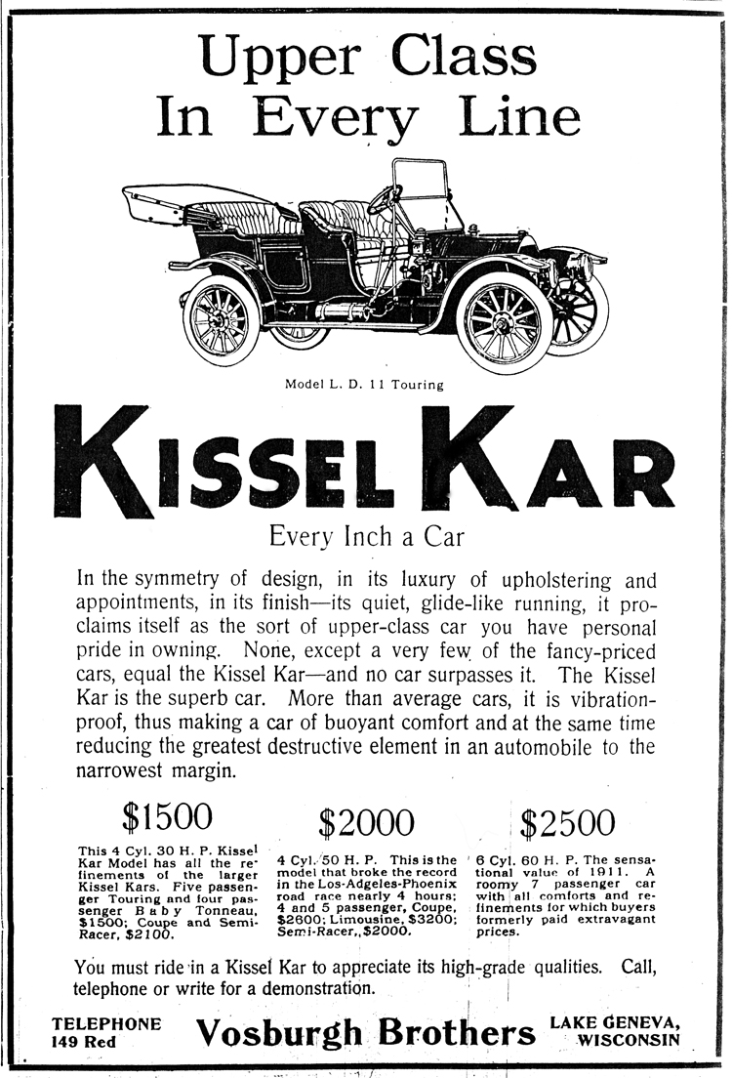

BUILDING ASSURED
HORTICULTURAL SOCIETY OBTAINS FINE LOCATION.

Bought South 120 Feet of the Hanna Property of S. B. Chapin - Structure of Architectural Beauty to be Erected Thereon - Remainder Fine Site for City Hall - City Better Buy.

A letter from S. B. Chapin states that he has conveyed to the Lake Geneva Horticultural Society the south 120 feet of the lots on the corner of Broad and Wisconsin streets, for $3500. That will give the society a parcel of land 120x120 feet in a very desirable location, on which, we understand, a beautiful building will soon be erected, so they will have a place in which to hold their annual flower shows, and for such other purposes as may be deemed expedient. We understand the plans for the building are about t o be completed and that they will call for a structure of architectural beauty, admirably adapted for the purposes for which it is designed.

Since the Horticultural Society has obtained the south part of that property there still remains a piece with a frontage of 120 feet on Wisconsin street and 52 feet on Broad street. So far as we know at present, there are no plans made for the erection of a building thereon. In this connection it seems to us, that it would be a wise move on the part of the city to purchase the remaining portion of that property for the purpose of erecting thereon a fine city hall. The location is ideal, and, that there is need of such a structure in this city, no one who knows the facts, will for a moment question. While we have no positive knowledge in the matter, yet we are satisfied that the property can be obtained for that purpose at a reasonable figure, and we hope to see some move made toward acquiring it at no distant day.

THE MINSTREL SHOW

The minstrel show that was put on the boards under the auspices of the local lodge of the Knights of Pythias last Tuesday night, was greeted by a packed house, every seat being sold before the performance began. The songs and the jokes were clean and much amusement was caused by the local bits which were made during the evening. The feats of hand balancing by Messrs. Foster and Johnson were excellent, and a surprise to many who did not know that those Lake Geneva boys had been practicing faithfully.

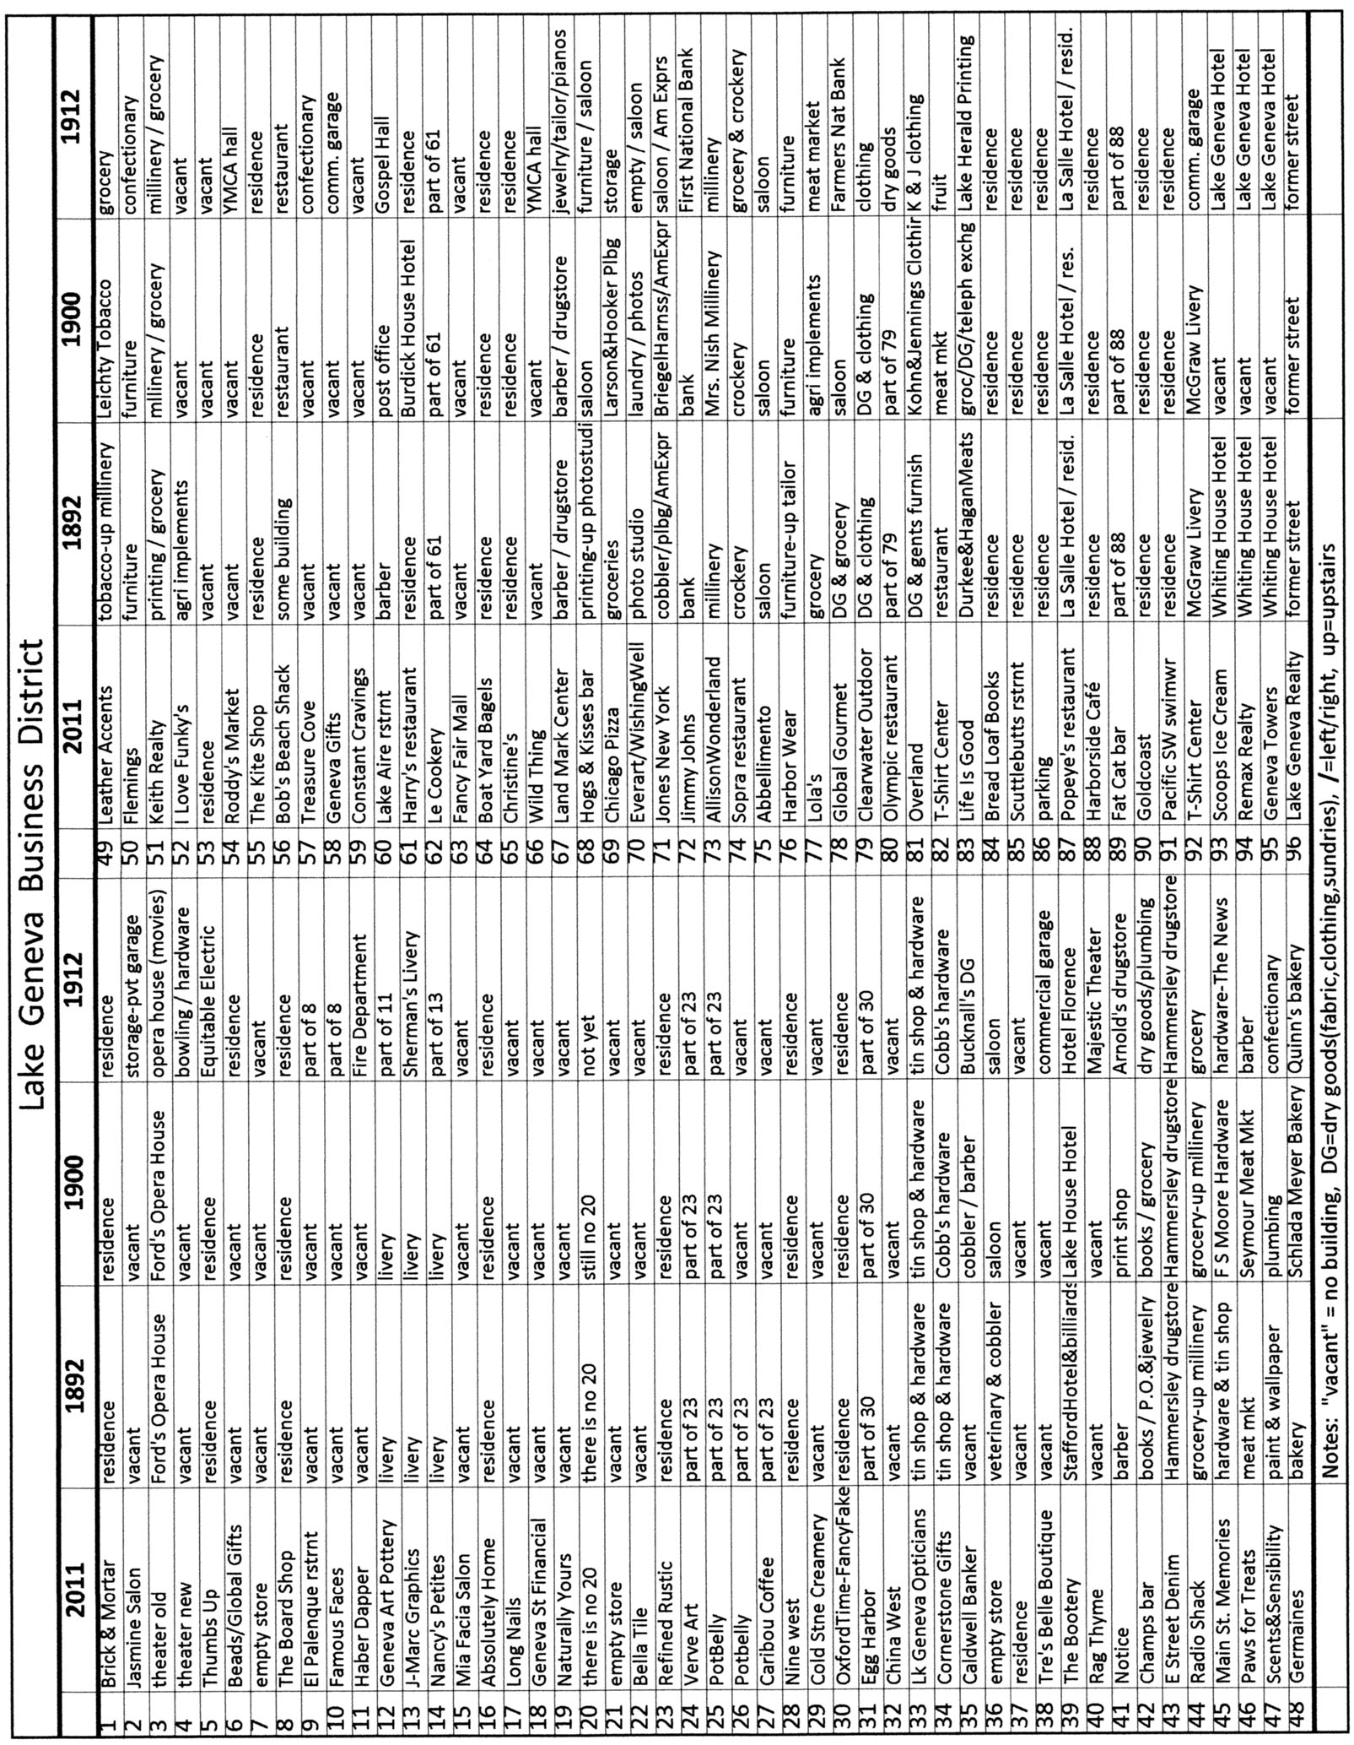

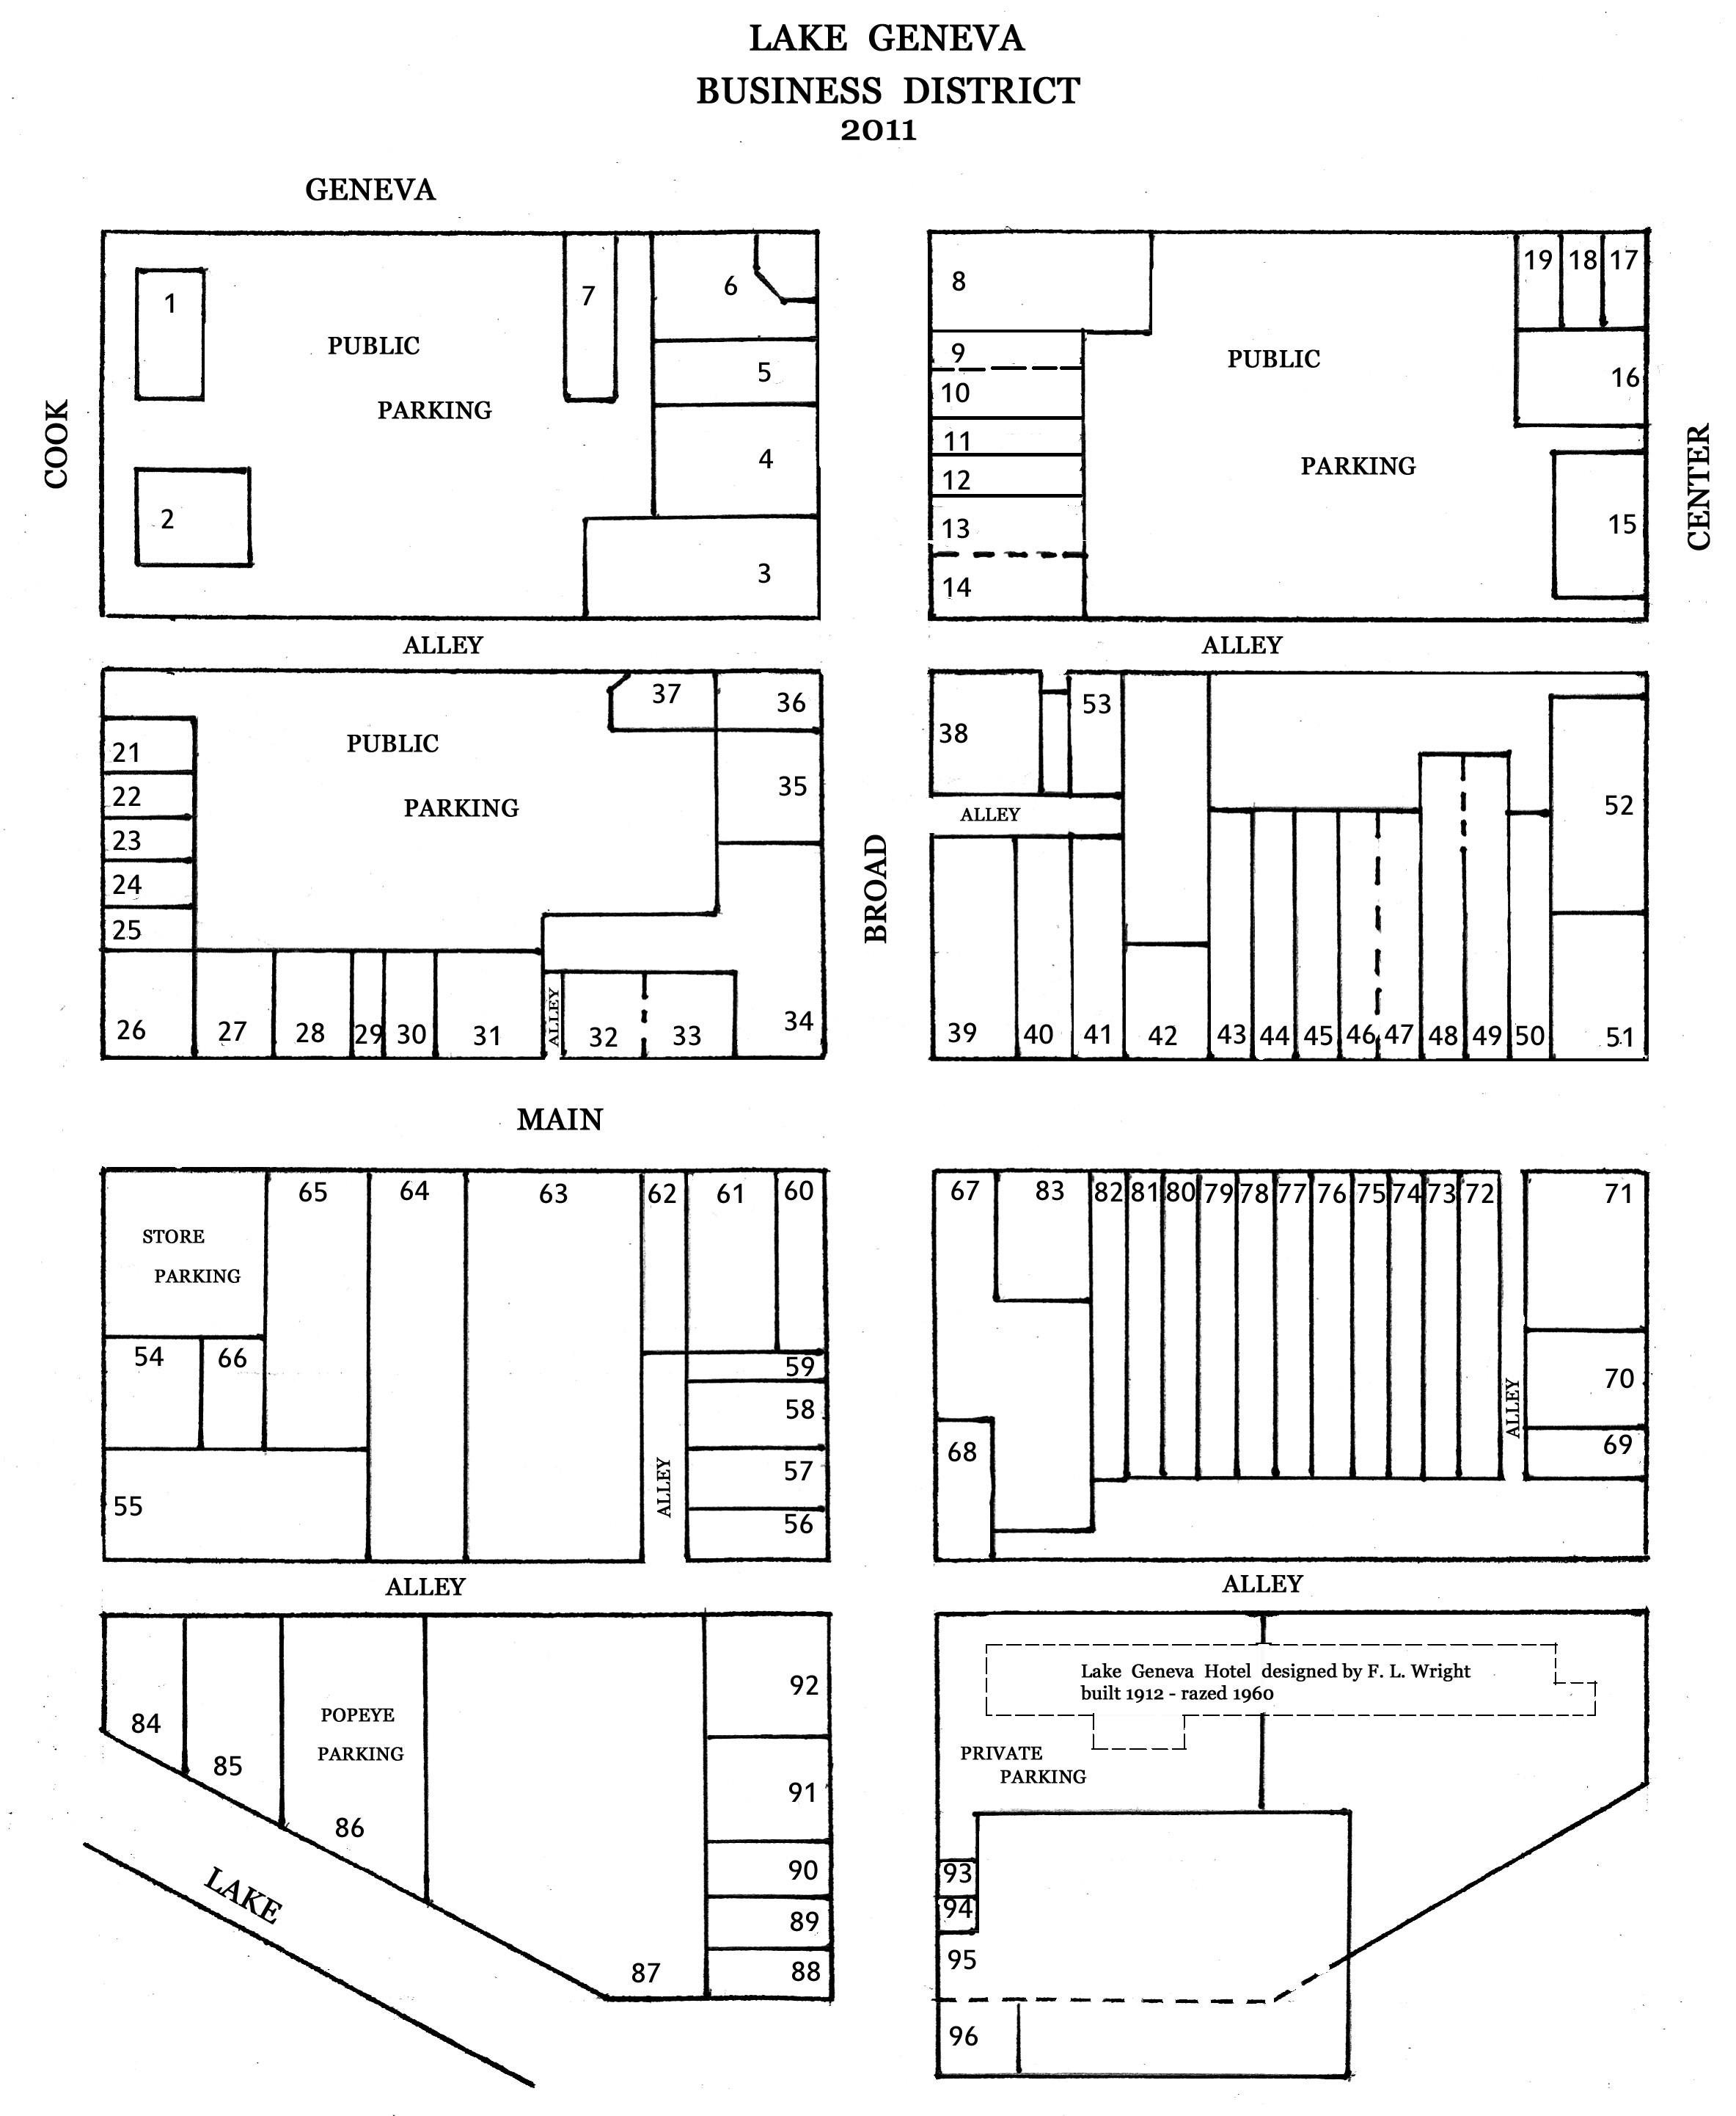

NEW HORTICULTURAL HALL

Ground Broken For Structure

For Gardeners Association.

ENTIRE LOT TO BE COVERED.

Ground was broken Last Tuesday for the new horticultural building which is to be erected for the Gardeners Association at he corner of Broad and Wisconsin streets.

The entire lot of 120x172 feet will be occupied. 30 feet on the north and about the same space on the east will be devoted to lawns and shrubbery.

The main building which will contain the exhibition hall and club room is 35x90 and on the west side is a kitchen 18 feet wide across the end of the building.

The architecture of this building will be the panel effect with rough cast finish.

On the south side will be a court 90x100 the walls of which will be cement block. The building will be heated by steam and electric lighted and will have all the modern conveniences.

THE LAKE GENEVA NEWS.

-PUBLISHED BY-

LAKE GENEVA PUBLISHING COMPANY

The woods are being raided by the young people for their store hickory and walnuts.

Work is advancing rapidly on the Horticultural hall. They are using a steam cement mixer and are able to turn out a large run of work.

The Woman's Club will meet at the Y. M. C. A. on Friday afternoon.

The horticultural hall is being pushed rapidly and it may be completed far enough for the chrysanthemum show to be held in November.

It will soon be so warm that three ice-cream sodas will be required for comfort, where one has sufficed before.

The first dance in Horticultural hall, first Wednesday night, was a perfect success, nearly 100 couples being present, and a jolly good time is reported.

There was considerable excitement last Monday when a span of horses ran east ton Main street and turned south at Center, though no damage was done.

The annual dahlia show will be held by the Gardeners and Foremens association in their hall, at the corner of Broad and Wisconsin streets, tomorrow afternoon.


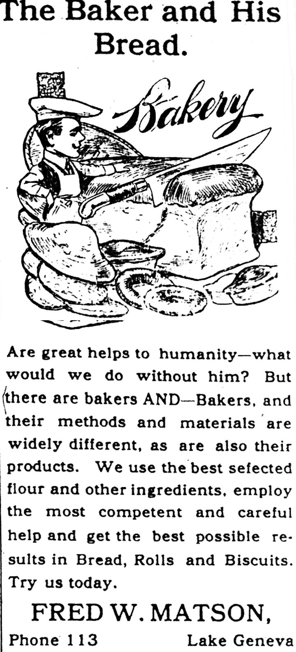
The Lake Geneva Old Times is sponsored and financially supported by the Lake Geneva Historic Preservation Commission. Each issue represents one year of authentic old news. It is free to the public. The public may obtain copies at the Geneva Museum, Grandma Vickie’s Café, Dunn Lumber, Piggly Wiggly, Caribou Coffee & Starbucks.
Editor, Denny Teichow, 262-248-6313.

