Vol. 4 - No. 8
Whole No. 44
Lake Geneva, Wisconsin, November, 1908


NEW USE FOR WINDMILLS.

Can Be Made to Supply House with Heat and Light.

Chief Wiley of the United States bureau of extension, believes the ordinary windmill can be used to greater advantage than at present. By properly harnessing the winds in the generation of electricity, he thinks the farmer will be able to light and heat his house, cook his meals and to furnish power for some of his lighter machinery. He said:

"The problem is simply that of harnessing the windmill properly--in order that it may deliver through the requisite machinery the energy which the breezes and storms supply. Electric heaters are already on the market--when once the harnessing of the windmill has been accomplished. There does not seem to be any good reason why the farmer's wife should not find the same source of energy for her cooking. As for lights the batteries will furnish the house and the barn. The winds which have hitherto gone almost entirely to waste will be a source of heat, light and power after the coal and oil wells are exhausted. Of coal and oil the supplies are necessarily limited, and are already threatening to give out, but the breezes will blow forever.

CONTEST IS CLOSED.
Much Friendly Rivalry Exhibited Toward the Last.
Miss Anna Stewart the Popular Choice for the Capital Prize--Miss Katherine LaSalle second.

The popularity contest is closed. The final count showed that Miss Stewart had a very large lead. The prizes offered were:

The Herald -- $400 piano

H. Rogers & Son -- $36 diamond ring
Kohn & Jennings -- $7 ladies suitcase
R. B. Arnold -- $5 Kodak
R. Briegel -- $6 plush robe
Fred Matson -- $5 in gold.

LAST FRIDAY'S FIRE.
THE LAKE GENEVA PIANO STOOL FACTORY.
Cause of Fire Unknown--Burned in the Middle of the Day--Filed with Manufactured Stock--A Total Loss--Partially Insured.

The Lake Geneva Piano Stool factory was destroyed by fire on Friday. The alarm was sent in to the power house by telephone by O. Davis, son of the proprietor, who was at the building and discovered the fire.

As near as we can learn the fire was first noticed on the second story, where a turning lathe and some of the saws were located, and nowhere near where any fire had the right to be.

The building was erected by John E. Burton in 1887 for the Florence Manufacturing Company and the Lake Geneva Knitting Mills. It was about 50x100 feet three stories, and had a brick engine room.

The business history of the factory a long and checkered one--some of the ventures being profitable while others have not. Some of the concerns which have operated the plant have been of benefit to the community while others, like Thomas Kane & Co. and Yale & Towne simply squeezed all they could get out of it "to remove competition"--and left Lake Geneva worse off than when they came.

About four years ago Sol Grollman came out from Chicago, rented the plant and began the manufacture of piano stools and benches. In he course of a couple years he was forced into bankruptcy and the business and stock passed into the hands of W. A. Davis, also of Chicago.

Te destruction of that plant is a serious blow to Lake Geneva--it was practically the only manufacturing enterprise in the city.

FACTS AND FIGURES
Given at Meeting Last Monday Night.

There was a goodly attendance at the opera house to hear the illustrated lecture on the licensing question by U. G. Umphrey, superintendent of the Wisconsin anti saloon league. He showed the degrading results of intoxicants, not only in cartoons but in actual photographs and then contrasted these with the palaces and luxury of the brewers and distillers for whom the poor drunkard works so hard.

He said Lake Geneva gets $4500 from nine liquor licenses. These saloons, in total, make about $67,000 per year. He then showed what $67,000 would buy in provisions and clothing.

AROUND ABOUT US
Items of News Gathered from Our Exchanges.

The dog poisoner is again busy in Delavan.

The industry of raising wolves seems to continue to prosper over Darien way.

Murder and suicide seem to be rampant at Waukesha -- three cases in six months.

Harvard physicians report an extensive run of the grip [flu].

The people of East Troy now enjoy theatre parties in Milwaukee because of the new railway.

The assessors found 2532 dogs in McHenry county, the town of Algonquin leading the way with 278.

For the benefit of the young ladies the Sharon Reporter publishes a list of the names of marriageable young men of that city.

Hog cholera is prevalent in the vicinity of Batavia, Ill., one farmer having reported the loss of six hogs.

A new boiler and engine has been put into one of the Delavan lake boats.

Whitewater citizens complain of too much water in their basements and too little in their cisterns.

East Troy has received its first car load of freight over the electric line.

Some thirty-five years ago, Harvard had a doctor who moved away owing a local druggist ten dollars. The other day the druggist received a check for thirty-five dollars from the doctor to pay up his old account.

Whitewater has not had a circus this season nor has it had a citizen lose his pocket book.

Harvesting the tobacco crop keeps the farmers of Rock County busy these days.

RELIABILITY RACE

Cars Passed Through Here at 8:20 - Left Chicago at 5:00 - Must Make 250 Miles a Day.

The annual four-day 1000 mile reliability contest for automobiles is being run off this week. Tuesday morning 19 automobiles were dispatched from Chicago Motor Club's official stand at Jackson boulevard and Michigan avenue. The cars were thoroughly inspected before the race and will be again at the end to prevent tampering or repairs.
PRESIDENT PRODS
CONGRESS AGAIN

Calls Its Attention to Laws He Urges Should Be Passed.
Devotes His Message, However, Almost Entirely to Corporation Control and Labor

[This was Teddy Roosevelt, a Republican.]

CHICAGO MILLIONAIRES FIGHT ICE COMPANY.

Invasion of the settlement of choice summer homes of Chicago millionaires at Lake Geneva, Wis, says an exchange, by a railroad switch track for the benefit of the Jefferson Ice company which seeks to erect several ice houses on the shores of the beautiful lake and to conduct an extensive ice business there, will be resisted in spite of an order of the Wisconsin state railroad commission, which authorized the construction of the switch track.

The proposed track and ice houses would be near the summer home of Charles H. Wacker, H. G. Selfridge, S. H. Wheeler, Dr. R. N. Isham and the estate of Otto Young.

Y. M. C. A. DOINGS
THE GOOD WORK CONTINUING IN EVERY LINE.

Rev. R. M. Morphett who was the guest of the Young Men's Christian Association over Sunday gave several interesting talks. He spoke on the subject of "Fighting the Lion." He gave four great lions which the young men of today had to fight. Impurity, selfishness, intemperance and gambling.

Monday night Rev. Morphett gave a stereopticon lecture on, "A Tour of Great Britain," to 200 people. His views were fine and he held the attention of the people throughout the lecture

Owing to the fact that the Woodstock basket ball team called off their game with the Y. M. C. A. on Friday night, two local games were played.

Sunday there will be a meeting addressed by C. V. Hibbard, one of the association secretaries in Japan. Mr. Hibbard is a graduate of the University of Wisconsin.

LENGTHEN THE SCHOOL YEAR

When it crowds the pupils and teachers to complete the course in nine months of school would it not be well to extend the school year a couple of weeks longer, making nine and a half months of school instead of nine? That is the question in the minds of our people, and we believe it should be done.

A POSTAL DEFICIT
THE POST OFFICE DEPARTMENT"S ANNUAL CRY.
The Same Old Story -- Always a Shortage -- Remedies Suggested -- Should Be Treated in a Business Manner

Postmaster General Meyer announces the postal deficit for the fiscal year amounts to 16,910,000. Mr. Meyer is "firmly convinced the establishment of a special parcel post , confined to rural routs, would tend to wipe out any postal deficit."

We must plead guilty of egotism enough to make us believe that we can give the postmaster general a couple of pointers which, if they do not provide a way to fully make up the alleged deficiency, they will go a long way toward it. The first is to cut off the franking privilege enjoyed by members of congress who frank almost everything from a collar to a threshing machine through the mails.

The second is for the post office to cease carrying free of cost the tons and tons of envelopes which are printed by the "government." There is no reason why the government should be allowed to do job printing and not be obliged to pay the postage for it like any other job printer.

The Bradley knitting Company, of Delavan, is calling for twenty-five girls and women to work in their factory. They have begun the erection of an addition to their factory, 84x52, two stories, and a basement. If you want work at good pay apply at once to the Bradley Knitting Company.

WADSWORTH -- GOING
Two Popular Young People Married in Chicago -- The Groom is a Lake Geneva Boy.

The marriage of Melvin Ray Wadsworth and Miss Grace May, daughter of Judge and Mrs. J. F. Going, was solemnized by Rev. H. W. Kerr, at the residence of the bride's parents in Chicago, last Wednesday evening.

The bride is a most estimable young lady of charming presence and a general favorite in the Chicago colony at the other end of our lake where she has spent her summers for the past several years.

The groom is the son of Mr. and Mrs. E. L. Wadsworth of this city where he lived as a boy and is known as a young man of good character and stability. He is graduate of our high school and later he took a couple of years at the state university.

Ray's many Lake Geneva friends wish for himself and wife long lives of happiness together, in which the Herald heartily joins.

The cost per capita per week of each inmate of the county farm and asylum according to the report of the superintendent is: Poor house, $2.23; asylum, $2.48.

FAMOUS HORSE CASE ENDS.

Racine, Wis. -- A jury in the celebrated horse case of Henry J. Kortendick against the town of Waterford brought a verdict in favor of the plaintiff for $122.50, the value of the horse, which was injured and died.

The case has been in the courts since 1904, and sufficient money has been expended in the litigation to buy forty horses.


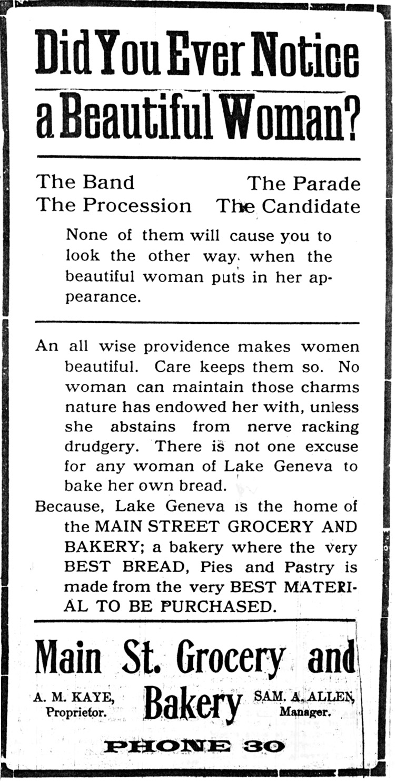


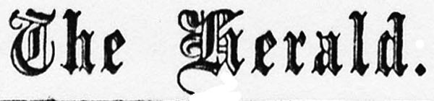

~~~~~~~~~~~~~~~~~~~~~~~~~~~~~~~~~~~~~~~~

JOHN E. NETHERCUT

~~~~~~~~~~~~~~~~~~~~~~~~~~~~~~~~~~~~~~~~

We understand that arrangements are being made to close the stores, beginning the first of the month, at 6 o'clock every night but Saturday.

The ladies of the Congregational church will serve a chicken pie supper Thursday from 5:30 to 7:30. Supper 25 cents.

It is said to be too dry for husking.

If you are a Republican join the Taft and Sherman club.

All the private steam yachts have been taken out of the wet and prepared for winter.

A new tin roof has been put on the Hill house, corner of Wisconsin and Cook streets, this week.

Hear the free concert given each evening at the Kimball piano agency on Broad street.

A. G.. Bain has been given a divorce from Hattie J. Bain for desertion.

Don't fail to hear the Prohibition candidate for president, E. W. Chafin, in this city at 10:15 Monday.

Barnett is showing a full line of bearskin Coats, Hoods, Tams and Leggins of best quality at very low prices.

Dr. Matter has moved his office to his residence in the Sanford house, second door east of the Baptist church on Geneva street.

With four or five work trains pulling into and out of this station besides all regular ones, Lake Geneva can be called a pretty lively railroad center.

The Association Chorus will not meet tonight because of the lecture which will occupy the room.

[The "Association" is the Y.M.C.A.]

The telephone company has just completed its second through toll line to Milwaukee, which will allow it to handle business with but little, if any delay.

The walk across the park has been completed and it is a good job. When the necessary grading and filling has been done a great improvement in the appearance of the park will have been made.

H. A. Cooper spent $999.12 to secure his nomination to misrepresent this district in congress--well that is not bad, for he will still have several thousands of his salary left to live on.

MYSTIC WORKERS NOTICE.

There will be an important meeting tonight, Friday, November 9. All Mystics are requested to attend.

FOR SALE.

Fifteen swarms of bees at $3.50 a swarm. They are in prime order; plenty stores for winter. New patent hives.

W. A. Boutell, Como, Wis.

NOTICE.

We will have a full supply of fish, and dressed poultry, for Thanksgiving. Place your order early.

Have you seen our sanitary oyster holder? Oysters shipped in sanitary cans and kept in a sanitary holder; save the natural flavor as they do not come in contact with the ice.

Use the Columbia Preservative Company's pure food mince meat for your Thanksgiving pies. Case & Stevenson

NOTICE.

The Lake Geneva Lodge, No. 6, of Pythian Sisters, will hold their next regular meeting on Tuesday evening. All members are requested to be present.

PERSONAL.

--Peter Hoag spent Sunday with his son in Racine.

--John S. Allen, wife and children, spent Saturday with relatives in Genoa Junction.

--Mrs. Henry S. Wilson, of Detroit, Mich., is the guest of Mrs. M. J. Wilson and daughter in our city.

--Maurice Durkee, C. W. French and Harold Douglass have gone to Madison to see the great football game tomorrow.

--Mrs. J. M. Parker, who had been visiting relatives at Neptune, Wis., last week has returned home accompanied by her mother, who will spend the winter in Lake Geneva.

--My store will be closed all day Thanksgiving day. Frank Johnson


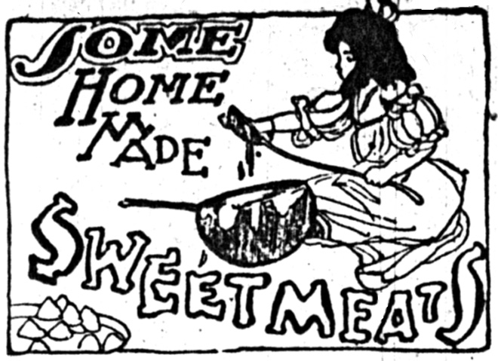

Banana Betty.-- Remove crust from a loaf of stale bread. Slice it as thin as possible. Place the slices in a dripping pan and brown very delicately in the oven, then spread with soft butter. Butter a baking dish and sprinkle it with buttered bread crumbs. Then add a layer of the toast, then a layer of bananas, peeled scraped and cut into quarters lengthwise. Sprinkle with sugar, a little cinnamon and a few drops of lemon juice and dot with butter. Repeat. Add a cup of boiling water, cover with buttered crumbs and bake in a moderate oven until the banana is tender. Keep covered until nearly done, then remove cover and brown. Serve with lemon sauce.

Try a box of "Never Darn" hosiery for men, women and children, (six pairs for six months). If you wear holes in them all you get six new pairs in exchange. Why not try it? Bucknall Bros.


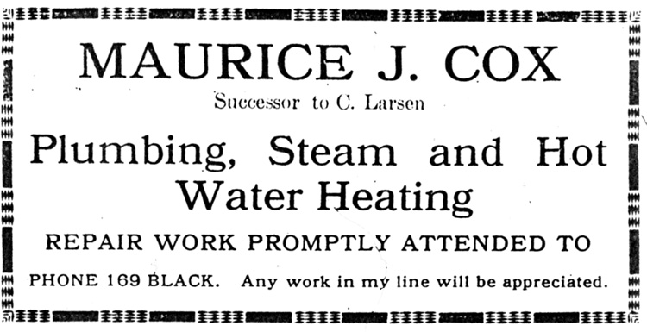

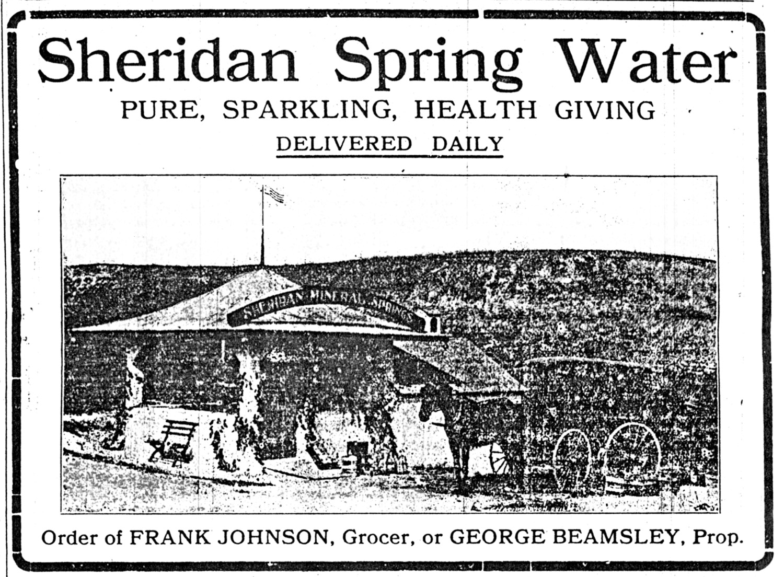


The Lake Geneva Old Times is sponsored and financially supported by the Lake Geneva Historic Preservation Commission. Each issue represents one year of authentic old news. It is free to the public. The public may obtain copies at the Geneva Museum, Grandma Vickie’s Café, Dunn Lumber, Piggly Wiggly, Caribou Coffee & Starbucks.
Editor, Denny Teichow, 262-248-6313.




